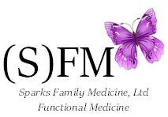

Please be aware that
SFM’s new cash pay fee schedule is effective as of March 1, 2016.

