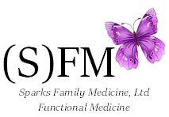

Sales Policy
Please inspect all sales. Sparks Family Medicine, LTD is unable to accept returns or provide refunds on products sold.
All sales are final.

All sales include Nevada Sales Tax

