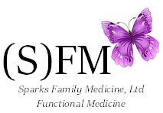

Sparks Family Medicine, Ltd.

Non-Discrimination Policy
We do not discriminate against race, creed, ethnicity or religion.

