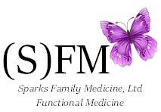
Amy R. Sparks, MD, IFMCP, ABIHM
Board Certified in Family Medicine
IFM Certified Practitioner
ABIHM Diplomate

10155 W. Twain Ave, Suite 110
Las Vegas, Nevada 89147
Phone (702) 722-2200
Fax (702) 722-2201

